Ramanujan Collage Delhi University

**MAXIMA PRACTICALS**

**Name**: Mozahidul Islam

**Roll No**. 20231459

**Subject**: Maths For computing

**Topic**: Practical’s Performed on Maxima

**Submitted To**: Dr. Aakash

INDEX

|  |  |  |  |
| --- | --- | --- | --- |
| **S.No.** | **Practical** | **Page no.** | **Remarks** |
| 1 | Practical 1: Create and transform vectors and matrices (the transpose vector (matrix) conjugate transpose of a vector (matrix)) | 3 |  |
| 2 | Practical 2: Generate the matrix into echelon form and find its rank. | 4 |  |
| 3 | Practical 3: Find cofactors, determinant, adjoint and inverse of a matrix. | 5 |  |
| 4 | Practical 4: Solve a system of Homogeneous and non-homogeneous equations using Gauss-  elimination method. | 6 |  |
| 5 | Practical 5: Solve a system of Homogeneous equations using the Gauss Jordan method. | 7 |  |
| 6 | Practical 6: Generate basis of column space, null space, row space and left null space of a matrix space. | 8 |  |
| 7 | Practical 7: Check the linear dependence of vectors. Generate a linear combination of given vectors of Rn/ matrices of the same size and find the transition matrix of given matrix space | 9 |  |
| 8 | Practical 8: Find the orthonormal basis of a given vector space using the Gram-Schmidt orthogonalization process. | 10 |  |
| 9 | Practical 9: Check the diagonalizable property of matrices and find the corresponding eigenvalue and verify the Cayley- Hamilton theorem. | 11 |  |
| 10 | Practical 10: Application of Linear algebra: Coding and decoding of messages using nonsingular matrices. | 12 |  |
| 11 | Practical 11: Compute Gradient of a scalar field. | 13 |  |
| 12 | Practical 12: Compute Divergence of a vector field. | 14 |  |
| 13 | Practical 13: Compute Curl of a vector field. | 15 |  |

* **Practical 1**: - Create and transform vectors and matrices (the transpose vector (matrix) conjugate transpose of a vector (matrix))

1. **Creating a vector(V) and matrix(M):** 
   1. To create a vector and matrix we use ‘matrix’ function.

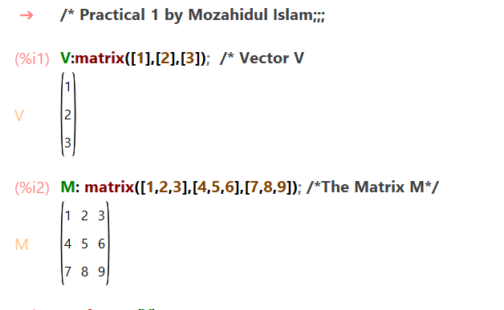

1. **Calculating transpose of vector(V) and matrix(M):** 
   1. To calculate transpose of a vector and a matrix we use ‘transpose’ function.

1. **Calculating conjugate of vector(V) and matrix(M)**
   1. To calculate conjugate of a vector and a matrix we use ‘conjugate’ function.

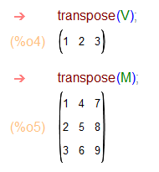

1. **Calculating conjugate transpose of a matrix**
   1. To calculate conjugate transpose of a matrix we use transpose (conjugate ()) function.

* **Practical 2**: - Generate the matrix into echelon form and find its rank.
  + 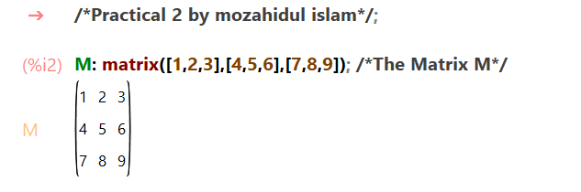Creating matrix
  + Echelon form

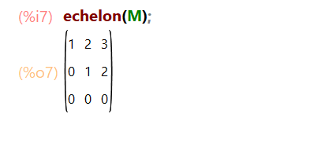

* + Finding Rank

* **A screenshot of a math problem

  Description automatically generatedPractical 3:** - Find cofactors, determinant, adjoint and inverse of a matrix.
* **Practical 4:** - Solve a system of Homogeneous and non-homogeneous equations using Gauss elimination method.



* **Practical 5**: - Solve a system of Homogeneous equations using the Gauss Jordan method.

1. Assigning the value of matrix to a variable named Coefficient_Matrix.

1. Assigning the value of Column matrix to a variable named Column_martix.

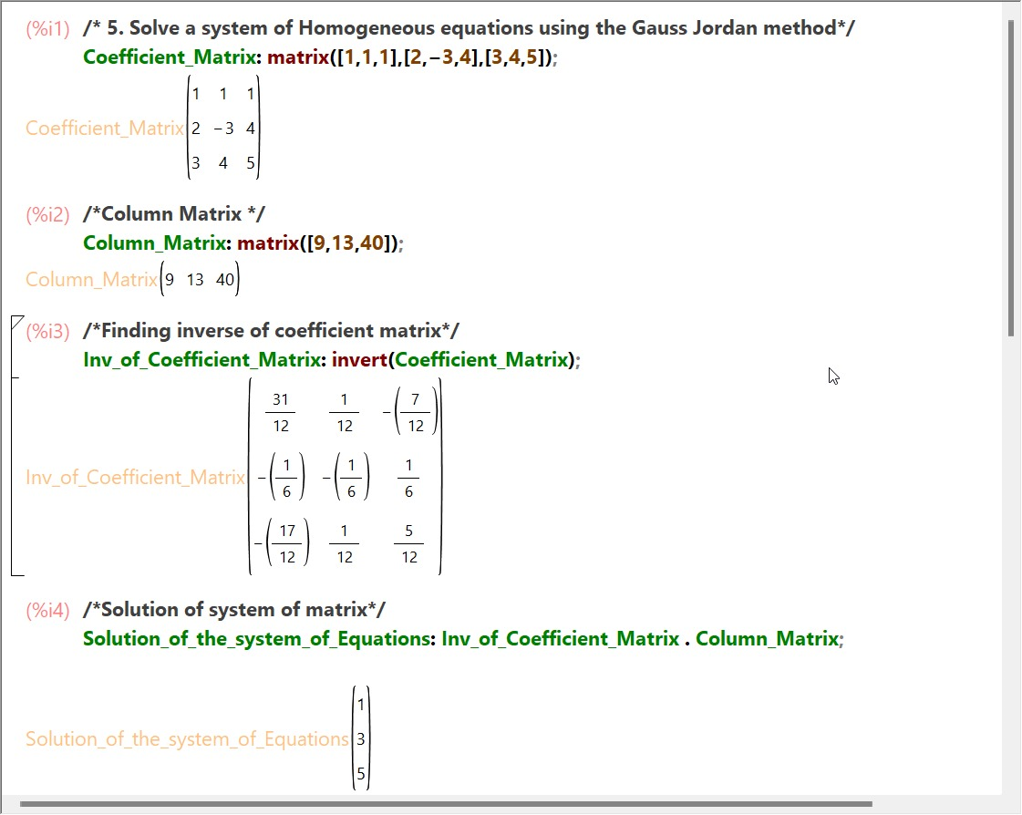

1. We will use the function invert for inversion process of matrix.

1. We will multiply the Inversed Matrix with the Column Matrix

* **Practical 6**: -Generate basis of column space, null space, row space and left null space of a matrix space

1. Create a matrix.

1. Basis of column space.

1. Create null space.

1. Row space.

1. Left null space.

* **Practical 7:** - Check the linear dependence of vectors. Generate a linear combination of given vectors of Rn/ matrices of the same size and find the transition matrix of given matrix space.

1. Checking linear dependence of vector.
   1. 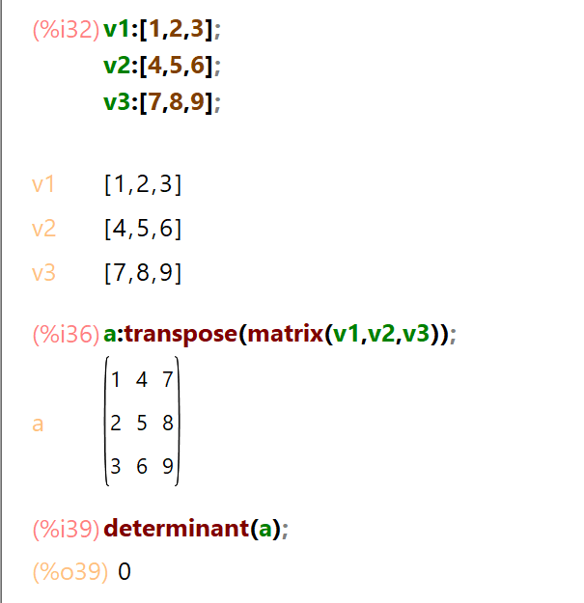Here determinant is zero, so the vectors are linearly dependent.
2. Generate a linear combination of given vectors of Rn/ matrices.

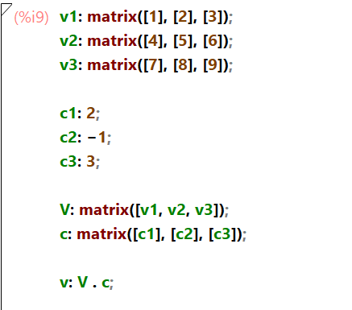

**Output:**

* **Practical 8:** - Find the orthonormal basis of a given vector space using the Gram-Schmidt orthogonalization process.

* **Practical 9:** - Check the diagonalizable property of matrices and find the corresponding eigenvalue and verify the Cayley- Hamilton theorem.



# 

* **Practical 10**: - Application of Linear algebra: Coding and decoding of messages using nonsingular matrices
  + code

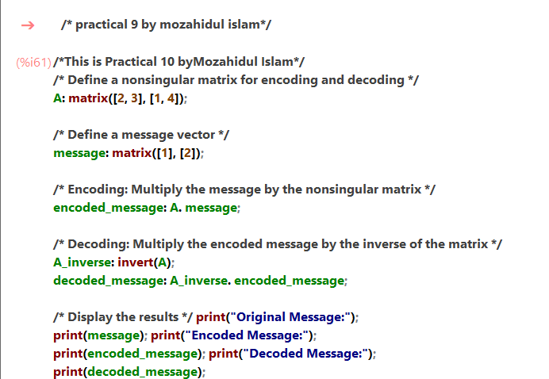

* + Output

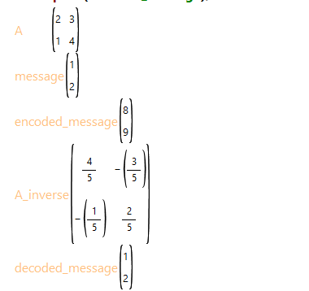

* **Practical 11:** - Compute Gradient of a scalar field.
  + Code

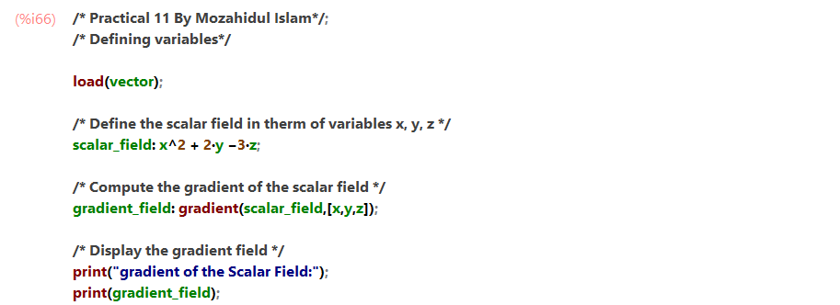

* + Output

* **Practical 12:** - Compute Divergence of a vector field.

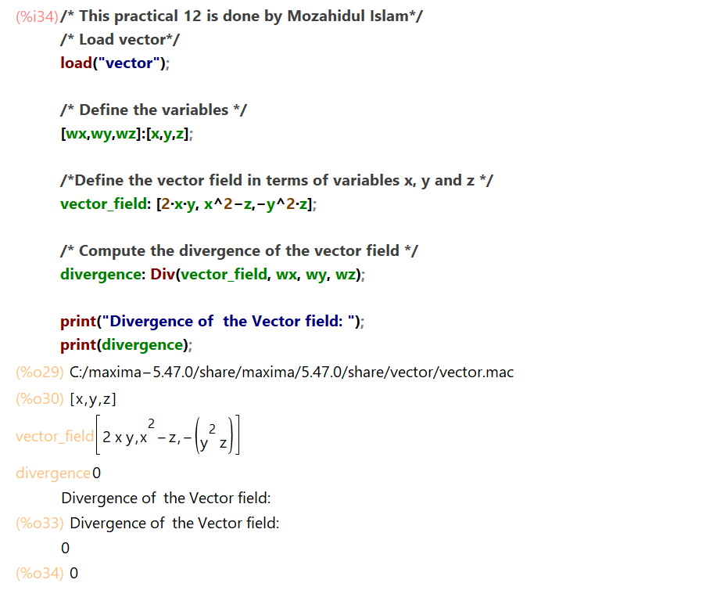

* **Practical 13:** - Compute Divergence of a vector field.

